E. Directing Edges
time limit per test
3 seconds
memory limit per test
256 megabytes
input
standard input
output
standard output
You are given a graph consisting of nn vertices and mm edges. It is not guaranteed that the given graph is connected. Some edges are already directed and you can't change their direction. Other edges are undirected and you have to choose some direction for all these edges.
You have to direct undirected edges in such a way that the resulting graph is directed and acyclic (i.e. the graph with all edges directed and having no directed cycles). Note that you have to direct all undirected edges.
You have to answer tt independent test cases.
Input
The first line of the input contains one integer tt (1≤t≤2⋅1041≤t≤2⋅104) — the number of test cases. Then tt test cases follow.
The first line of the test case contains two integers nn and mm (2≤n≤2⋅1052≤n≤2⋅105, 1≤m≤min(2⋅105,n(n−1)2)1≤m≤min(2⋅105,n(n−1)2)) — the number of vertices and the number of edges in the graph, respectively.
The next mm lines describe edges of the graph. The ii-th edge is described with three integers titi, xixi and yiyi (ti∈[0;1]ti∈[0;1], 1≤xi,yi≤n1≤xi,yi≤n) — the type of the edge (ti=0ti=0 if the edge is undirected and ti=1ti=1 if the edge is directed) and vertices this edge connects (the undirected edge connects vertices xixi and yiyi and directed edge is going from the vertex xixi to the vertex yiyi). It is guaranteed that the graph do not contain self-loops (i.e. edges from the vertex to itself) and multiple edges (i.e. for each pair (xi,yixi,yi) there are no other pairs (xi,yixi,yi) or (yi,xiyi,xi)).
It is guaranteed that both sum nn and sum mm do not exceed 2⋅1052⋅105 (∑n≤2⋅105∑n≤2⋅105; ∑m≤2⋅105∑m≤2⋅105).
Output
For each test case print the answer — "NO" if it is impossible to direct undirected edges in such a way that the resulting graph is directed and acyclic, otherwise print "YES" on the first line and mm lines describing edges of the resulted directed acyclic graph (in any order). Note that you cannot change the direction of the already directed edges. If there are several answers, you can print any.
Example
input
Copy
4
3 1
0 1 3
5 5
0 2 1
1 1 5
1 5 4
0 5 2
1 3 5
4 5
1 1 2
0 4 3
1 3 1
0 2 3
1 2 4
4 5
1 4 1
1 1 3
0 1 2
1 2 4
1 3 2
output
Copy
YES
3 1
YES
2 1
1 5
5 4
2 5
3 5
YES
1 2
3 4
3 1
3 2
2 4
NO
Note
Explanation of the second test case of the example:
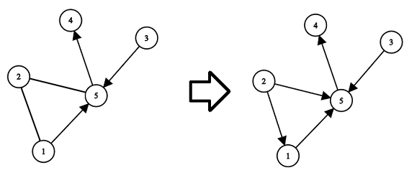
Explanation of the third test case of the example:
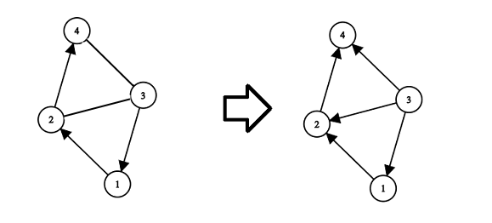
思路：拓扑序、有向图判环。
有向图判环大家都很熟悉，就是跑一边拓扑排序，看最终加入队列的点数是否等于总点数。
第二个是给环添加方向的做法。
这让我想起了学网络流时的dinic算法。也就是选取一点dfs，得出所有点的深度，然后路线只能从浅向深移动，这样避免成环，我的思路正是受这启发。
这里就不用多写dfs了，用拓扑序（可以理解为深度）解决即可。

#include<bits/stdc++.h>
#define ll long long
using namespace std;
const int N=200010;
int dep[N];
int in[N];
struct node
{
int x,y;
};
int n,m;
vector<node> ask;
vector<node> ans;
vector<int> G[N];
bool topsort()
{
int num=0;
queue<int> que;
for(int i=1;i<=n;i++) if(!in[i]) que.push(i);
int ct=0;
while(!que.empty())
{ ct++;
int now=que.front();
dep[now]=ct;
que.pop();
for(int i=0;i<G[now].size();i++)
{
int to=G[now][i];
in[to]--;
if(!in[to])
{
que.push(to);
}
}
}
return ct==n;
}
int main()
{
int t;
scanf("%d",&t);
while(t--)
{
scanf("%d %d",&n,&m);
for(int i=0;i<=n;i++) { in[i]=0;dep[i]=0; G[i].clear();}
ans.clear(); ask.clear();
int tt,u,v;
for(int i=1;i<=m;i++)
{
scanf("%d %d %d",&tt,&u,&v);
if(tt==1)
{
in[v]++;
ans.push_back((node){u,v});
G[u].push_back(v);
}
else
{
ask.push_back((node){u,v});
}
}
if(!topsort())
{
printf("NO\n");
continue;
}
for(int i=0;i<ask.size();i++)
{
node tmp=ask[i];
if(dep[tmp.x]>dep[tmp.y])
{
ans.push_back((node){tmp.y,tmp.x});
}
else ans.push_back((node){tmp.x,tmp.y});
}
printf("YES\n");
for(int i=0;i<ans.size();i++)
{
printf("%d %d\n",ans[i].x,ans[i].y);
}
}
return 0;
}

